SAVEETHA SCHOOL OF ENGINEERING
CSA15- CLOUD COMPUTING AND BIG DATA ANALYTICS
LIST OF EXPERIMENT 2
Name: Edrin J S
Register_Number:192524041
Course Code:CSA1504
2. Build a basic cloud-based Flight Reservation System with any Cloud Service Provider, in order to demonstrate the SaaS model.
Aim
To design and build a cloud-hosted Flight Reservation System built on Zoho Creator and roll it out as a Software as a Service (SaaS) application, so that users can book, manage, and track flight reservations over the internet.
Procedure
- Sign in to Zoho Creator with a valid Zoho account.
- Start a new application called Flight Reservation System.
- Build the following forms:
  - Passenger Information
  - Flight Information
  - Booking Details
- Include the required fields such as Passenger Name, Email, Mobile Number, Flight Number, Source, Destination, Travel Date, Seat Class, and Booking Status.
- Set up reports to show available flights along with the reservation details.
- Set up workflows that handle booking confirmations and validate the entered data.
- Define user roles and permissions so administrators and users each have secure, appropriate access.
- Publish the completed application to the Zoho cloud platform.
- Verify the application by creating, editing, viewing, and cancelling flight bookings through the web interface.

Snapshots:
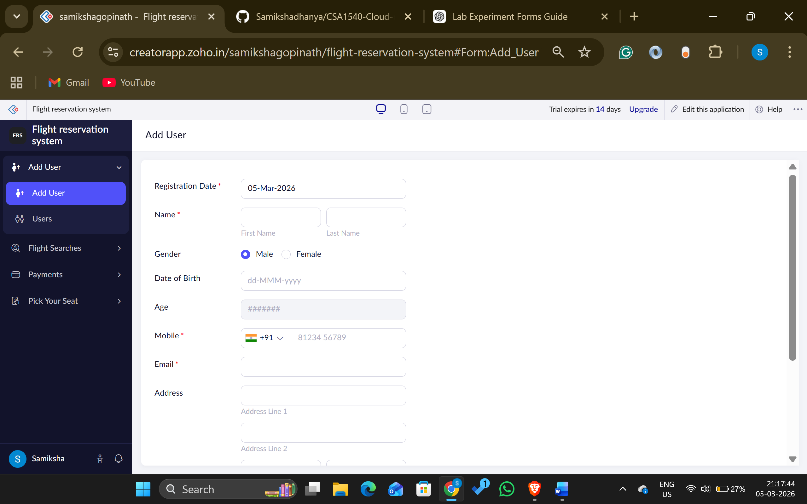
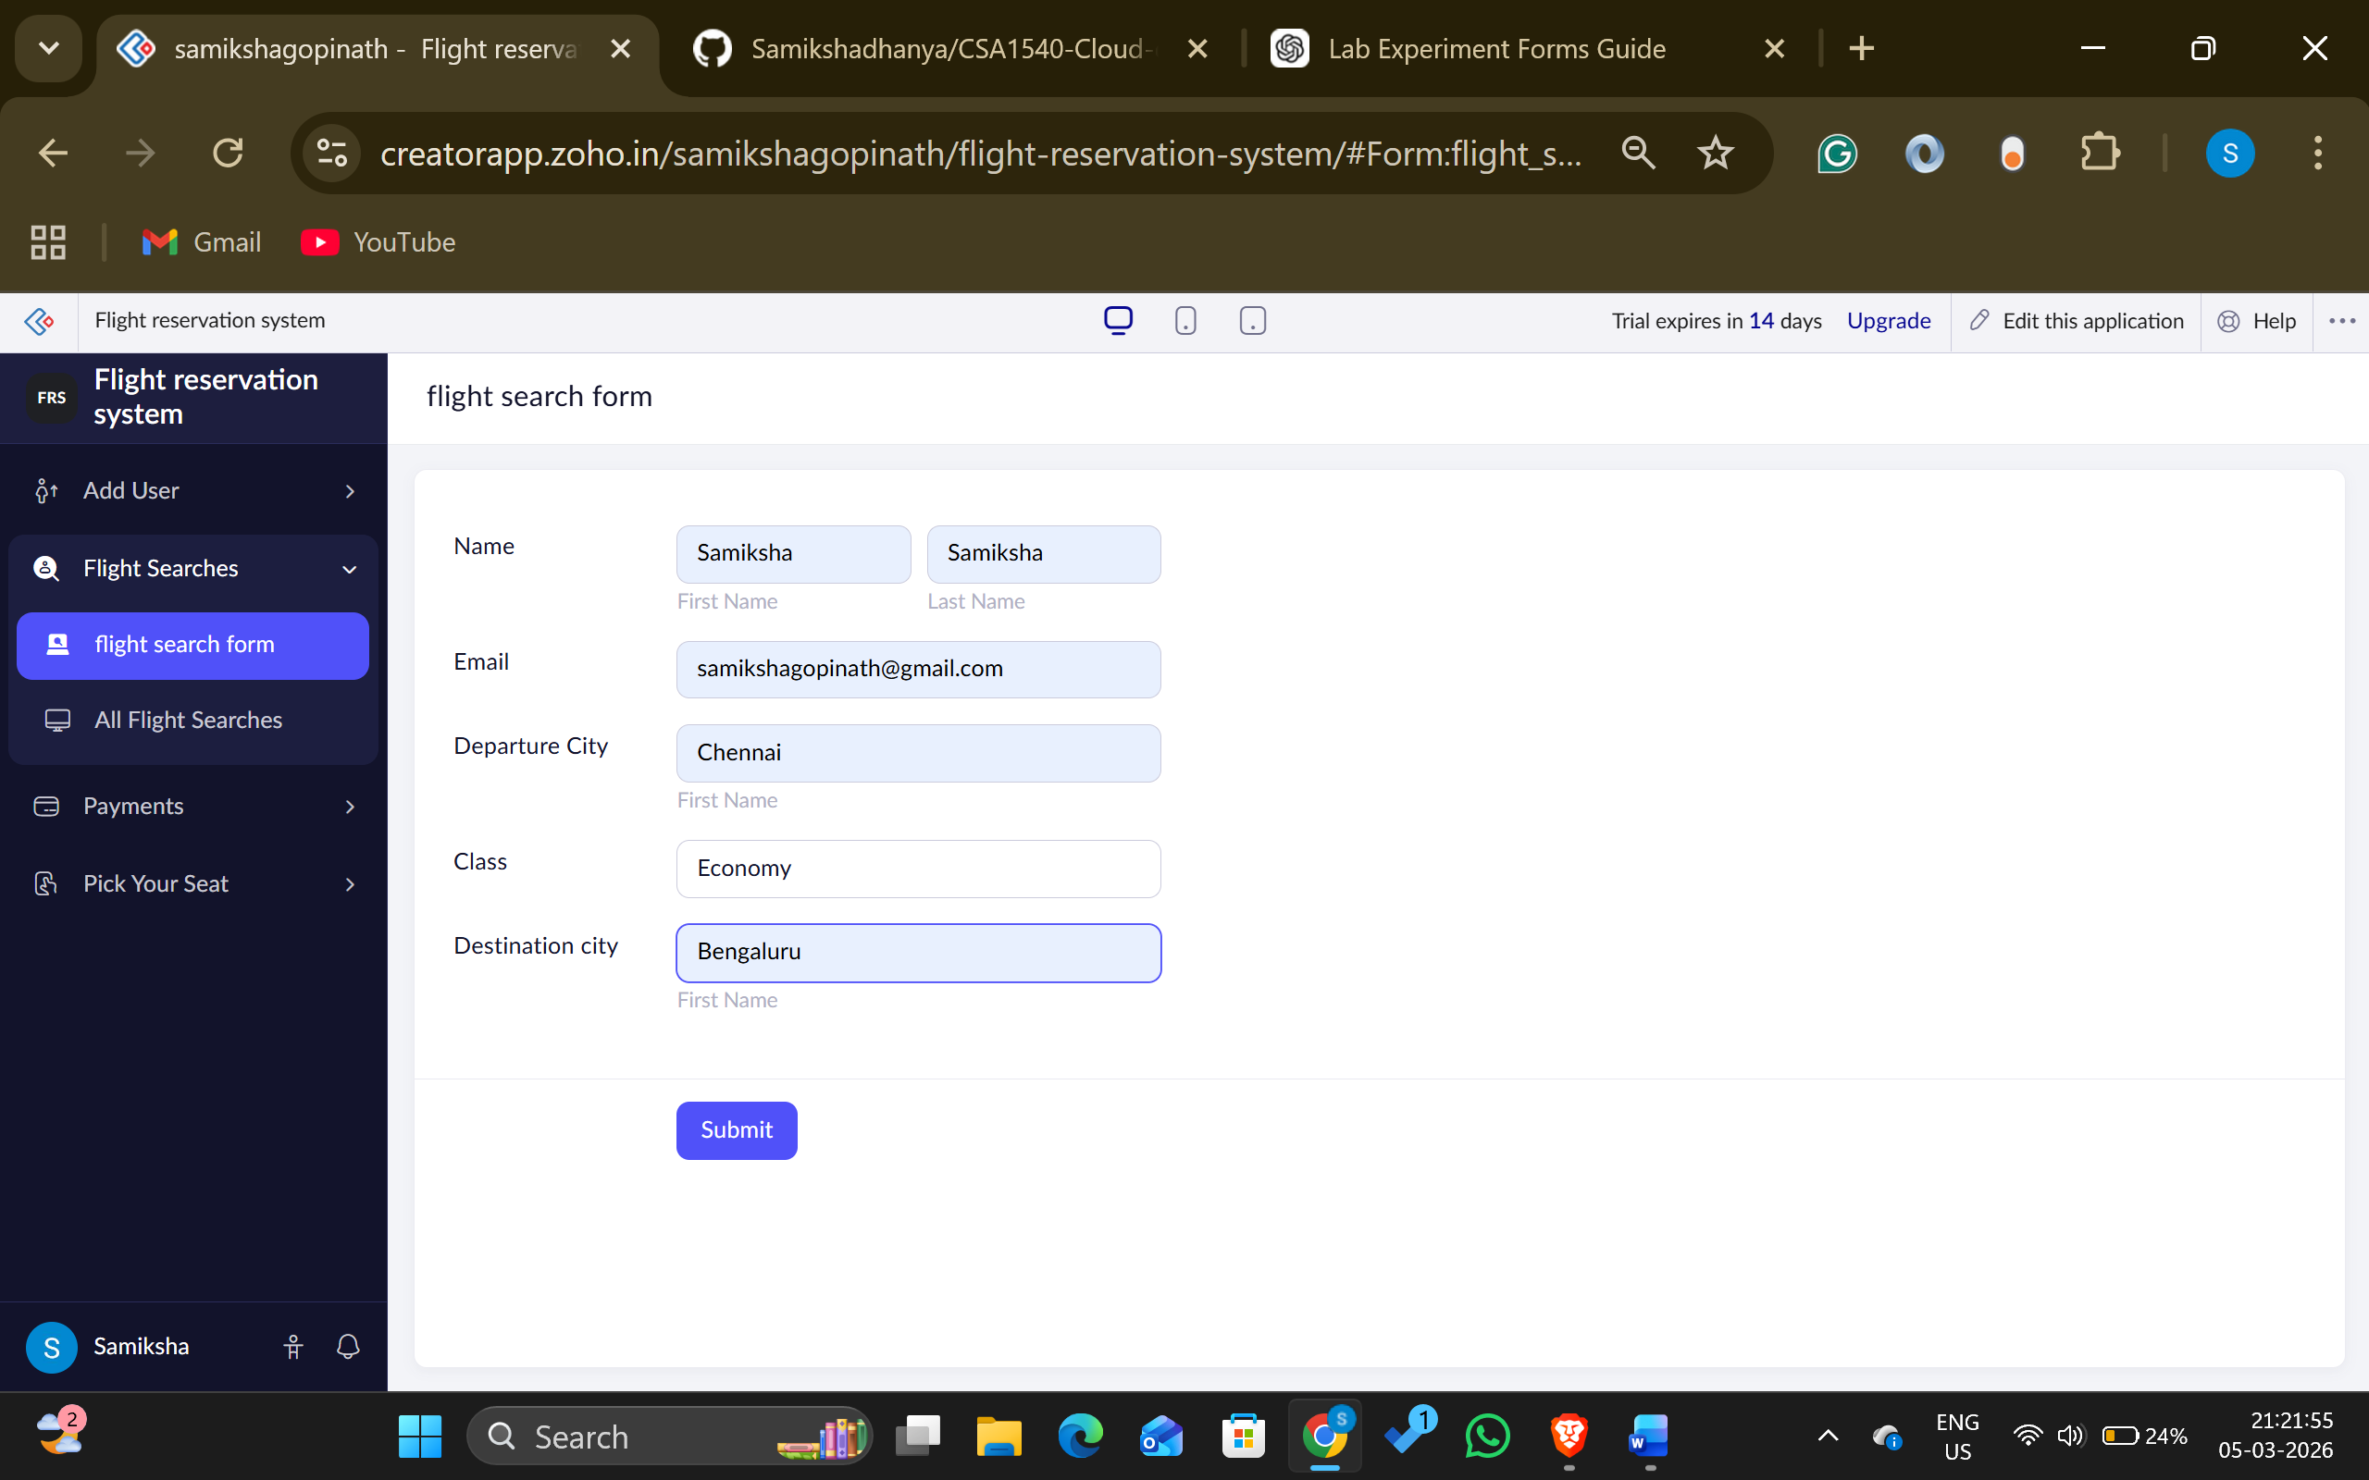
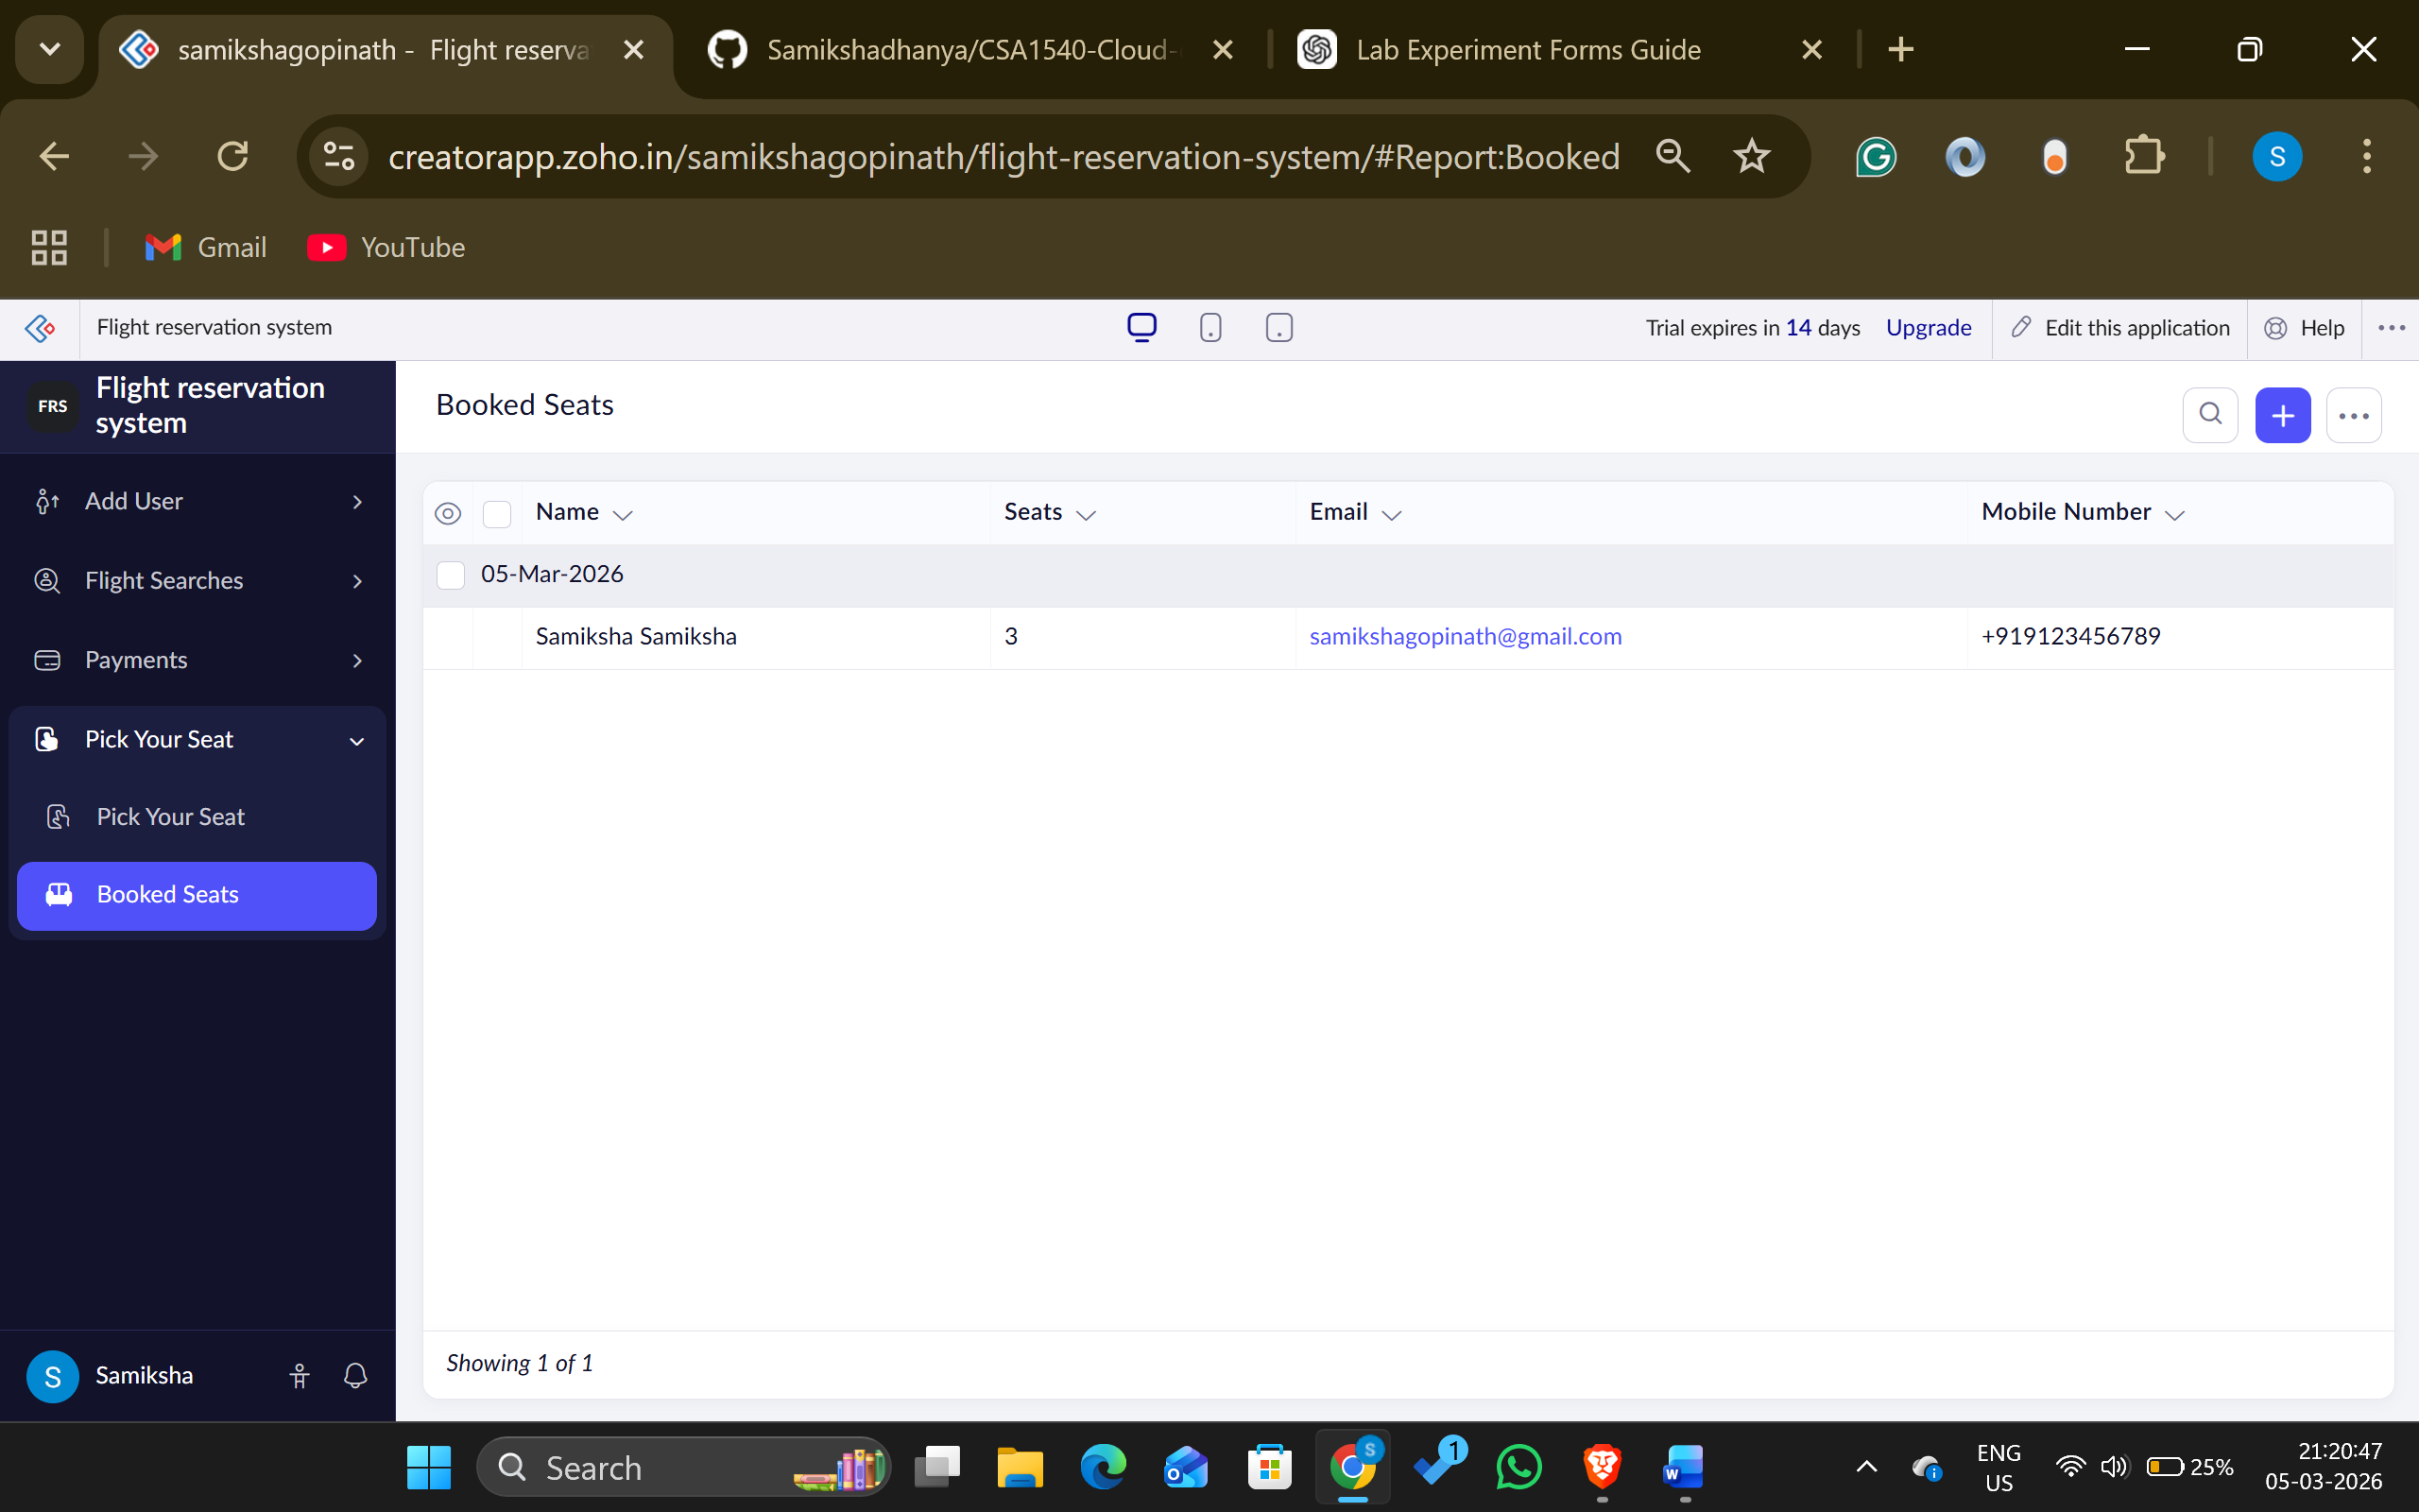

Result:
A cloud-hosted Flight Reservation System was successfully built and deployed using Zoho Creator. Users were able to reserve and manage their flight bookings online through a web browser, confirming the Software as a Service (SaaS) model by offering access from anywhere, at any time, with no local installation needed.

